University of Cumbria Students’ Union Operational Report

2nd May – 30th June 2019

Introduction

With the union ending another academic year, we say goodbye to some sabbatical officers and welcome new ones to join our team. The next month will be focused on training these officers, as well as planning everything we wish to deliver over the following year.

We continue to work in line with our charitable objectives, categorizing all of our work into four sections:
- Removing barriers to students’ accessing and leading their Students’ Union no matter where or how they study.
- Be recognised by students’ as a visibly effective representative organization.
- Delivering relevant, quality services, opportunities and activities that meet student need.
- Be an assertive and forward looking partner to the University of Cumbria and the communities in which our students’ live and study.

It has been nearly a year since the employment of our Campus Community Developer roles and we are receiving more and more positive feedback and engagement with the student bodies on Brampton Road and Ambleside. These roles are becoming increasingly useful with the planning of our Welcome period.

Following from the NSS (National Student Survey) for last year and as we await this years we continue to take steps to increase the quality and quantity of student feedback that we receive through the academic representation system. With the hope to increase student engagement and satisfaction at the university, we are also planning our Welcome ’19 period events, with one week of focused events and ‘pre-welcome’ events for early starters and Postgraduate students.

With the democratic review research completed we await student feedback on the options before putting the final choice to a referendum vote at the beginning of next academic year.

As this year academic year draws to a close and we begin to plan for the following cycle we remain committed to providing our support services to a high standard as well as giving students opportunities to get involved in volunteering, groups, and having their voice in the university.

Matthew Wisener – Community & Partnership Sabbatical Officer Trustee and Student Director

UCSU Volunteering Report: May – June 2019

- New Student Registrations

Since May 2019 11 new students have registered on the volunteering platform.

- New Organisation Registrations

Solomons Europe registered their Fit District Festival event, a free one off festival focussed on health and wellbeing. They are looking for student volunteers to support but have also invited people to attend as guests.

In June, More Music Morecambe joined the volunteering platform and added their opportunities for Catch the Wind Kite Festival Volunteers. Following a post on Twitter about the opportunity we were retweeted 15 times by a number of local organisations, some of whom now follow us on Twitter, including Lancaster Fun Palace (event in October) Morecambe and Lancaster Fun, Morecambe Beach Buddies, Morecambe Prom, More Music, Morecambe Visitor Information Centre, Morecambe BID and Visit Morecambe Bay.

- New Volunteering Opportunities Added

Kith and Kids, our London based volunteering opportunity, added Autism Summer Camp Volunteer 2019 and Weekend Club Autism Support Volunteer opportunities to the website. *****Any support with getting this out to our London students would be welcomed******

On 29th May Chris Barlow, Senior Lecturer in Education asked for help to find student volunteers to support his event on 6th June. The event involved 400 kids coming to take part in a Flood Awareness Day on campus. We were able to find 2 students volunteers, through facebook, and paid for one of the volunteers to travel from the Fusehill Street site. Please see below an article from Myfanwy about the day:
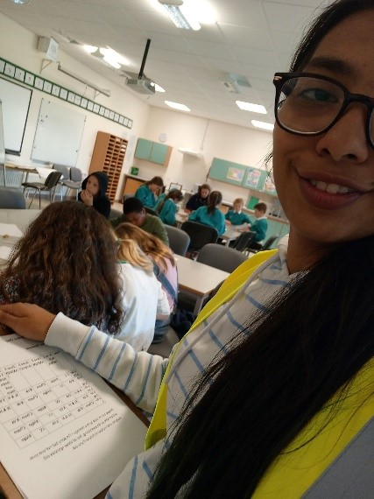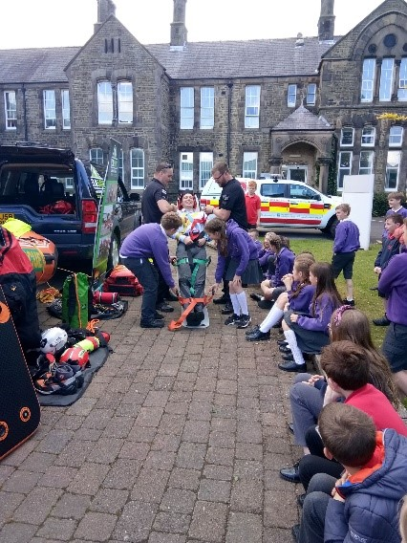

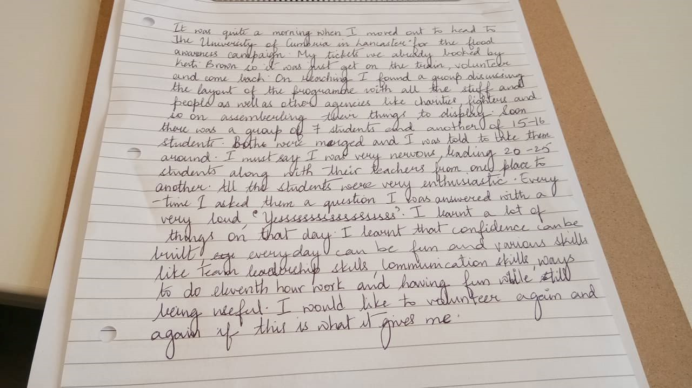

- Volunteering Applications

Between May and June there have been 27 applications made for various opportunities on the volunteering platform. The most popular volunteering opportunity is currently Welcome Helpers, with 41 applications in total. Other opportunities people have applied for include Media volunteers with Eden Mind and the Cumbria Law Centre Law Students Project 2019/2020

- Eleanor Peel Applications
There is currently only £624 funding remaining in the Eleanor Peel Trust, 12 awards have now been made, most recently awarding an Lancaster OT student, Susie Martin, funding towards volunteering abroad costs to volunteer in Muhimbili National Hospital, Tanzania.
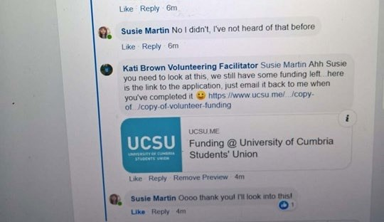
- We have now received our first report from a recipient of the Eleanor Peel funding. Sonja travelled to India to put her Occupational Therapy skills to the test, volunteering with a team to support Leprosy patients.
https://ucsuvolunteering.wordpress.com/2019/06/17/volunteering-with-the-leprosy-mission/

- Feedback
Students continue to engage with facebook and this demonstrates the important of sharing University and Students’ Union messages in a variety of places.
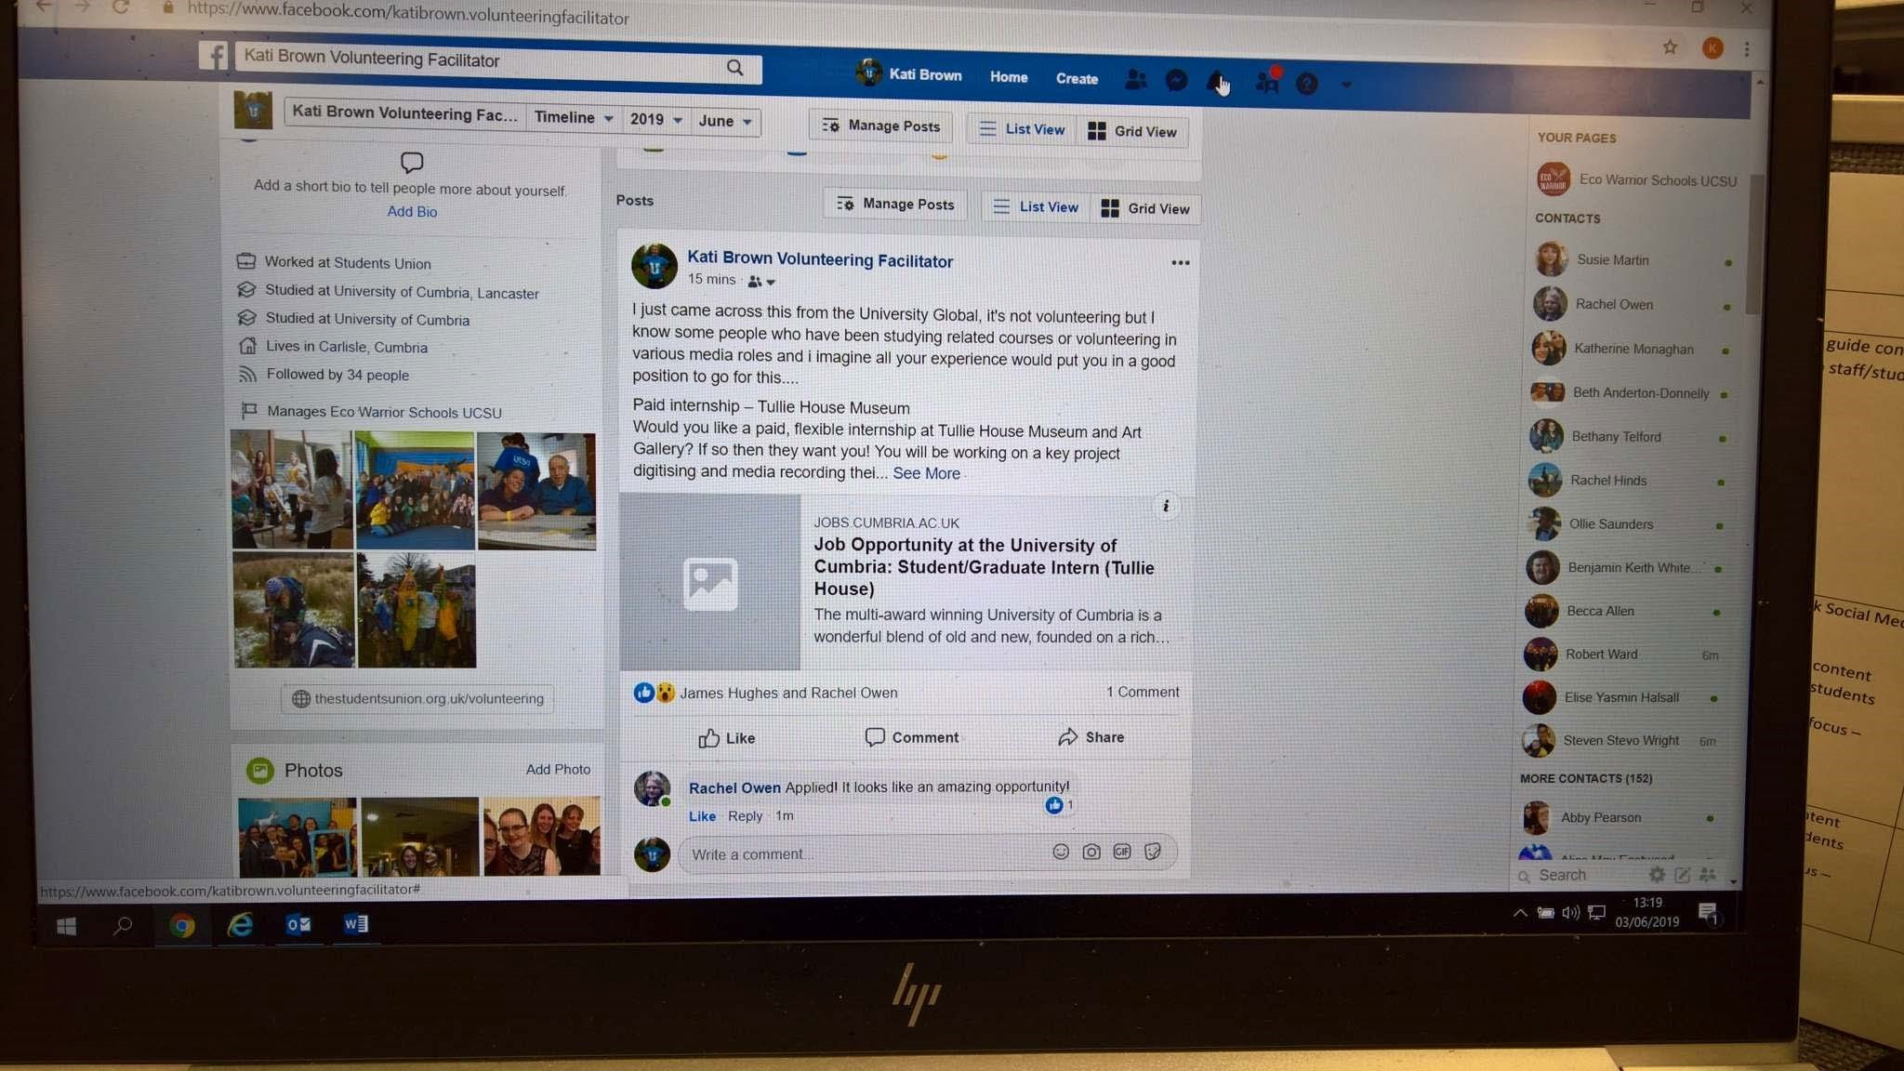
Positive Feedback….
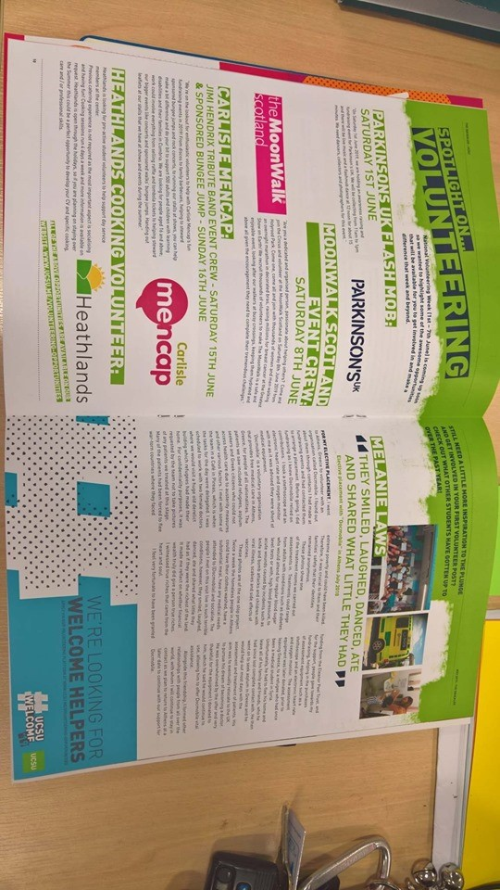

Eco schools Project: Ambleside

Although our Eco Project team in Ambleside have now finished their courses and some will be graduating soon, they are continuing to run the Eco Schools Project over the summer in partnership with Ambleside Primary School.

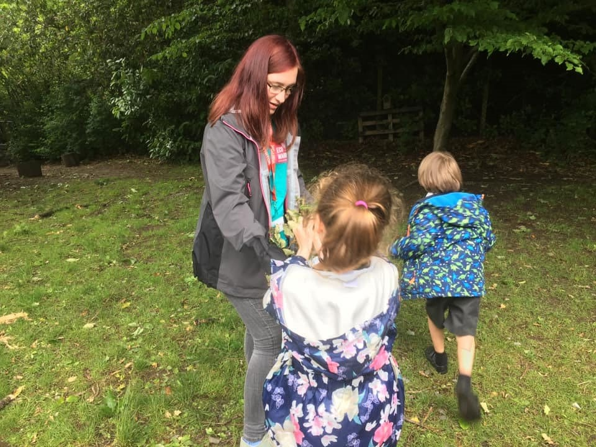

You can read more about the Eco Project and all the volunteering activities the Conservation have been up to this year on the UCSU Blog: https://ucsuvolunteering.wordpress.com/2019/06/17/a/

Twitter Analytics April 2019
New followers on Twitter in June include: UoC Physiotherapy, Lancaster Chamber, Howgill Family Centre, and Hardknott Forest.
On 21st June Twitter Analytics gives the following 28 day summary for @suvolunteering
Tweets: 30 (+42.9%)
Tweet impressions: 19k (+70.6%)
Profile Visits: 349 (+45.4%)
Mentions: 23 (-23%)
Followers 766 (+14)

On 14th June Twitter Analytics gives the following 28 day summary for @suvolunteering Tweets: 26 (+89.5%)
Tweet impressions: 21.5k (+203%)
Profile Visits: 407 (+126%
Mentions: 28 (+40%)
Followers 762 (+11)

On 1st June Twitter Analytics gives the following 28 day summary for @suvolunteering:
Tweets: 26
Tweet impressions: 13.5k (+2.5%)
Profile Visits: 316 (+26%)
Mentions: 28 (+55%)
Followers 754 (+9)

On May 22nd Twitter Analytics gave the following 28 day summary for @suvolunteering:
Tweets: 17
Tweet impressions: 10.5k
Profile Visits: 194
Mentions: 21
Followers 752

We continue to engage with organisations in the places our students study, gaining new followers, and promoting events, support services and volunteering opportunities.

COMMUNITY ENGAGEMENT
The most popular posts on social media show engagement with the community and showcase the range of opportunities available through real people doing real, interesting, and fun things. At the end of May our top Media Tweet was following a post from a festival I attended in Manchester called Envirolution (featuring a picture of the Vegan Cake). The album I posted with pictures from the festival have also gained the second most engagement of my facebook posts in May, the most popular being where I asked students to share their own experiences of volunteering in their communities.
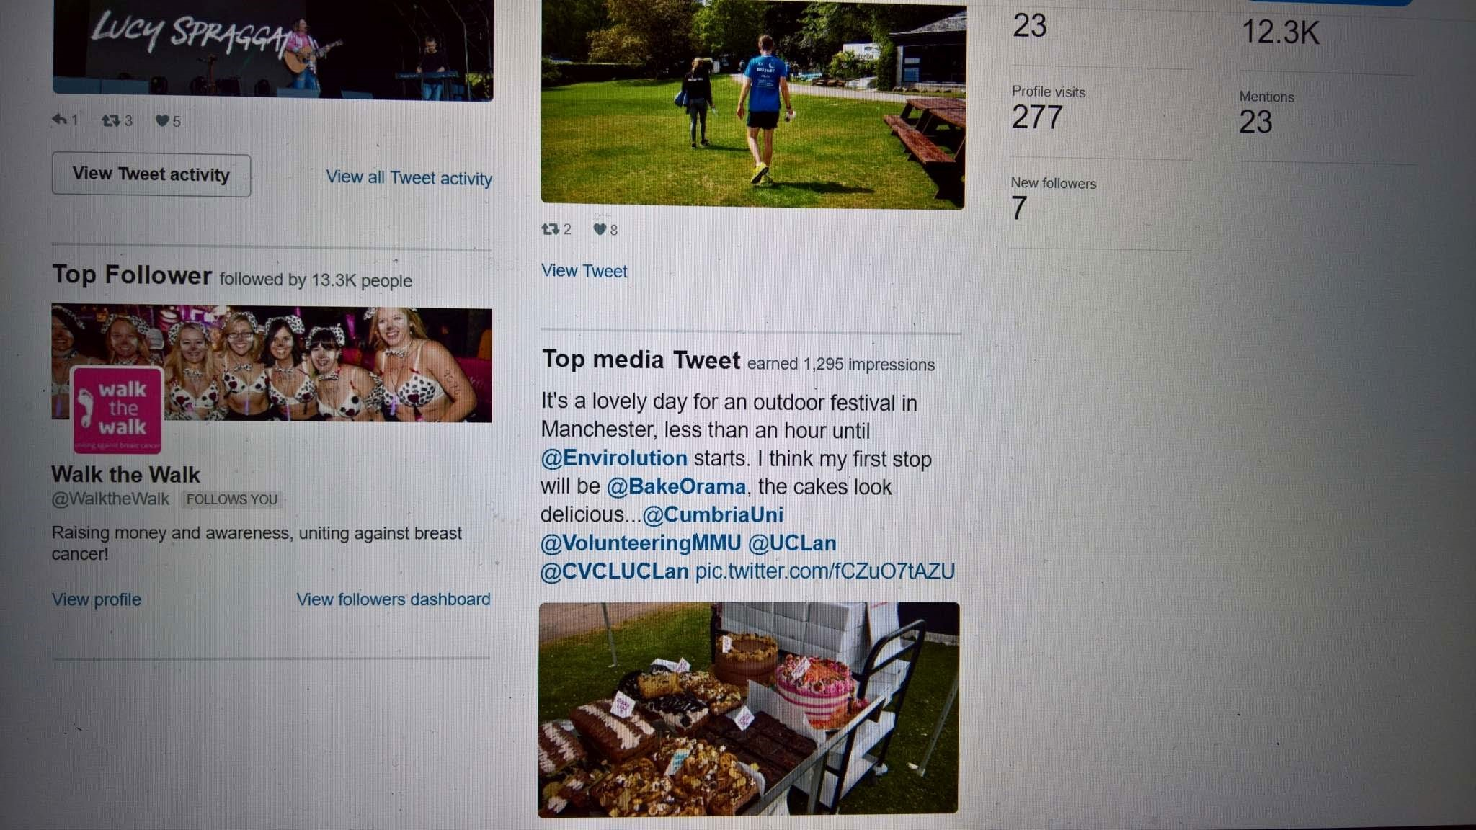

- Welcome Helper Final Update: 40 (w/c 17th June)

- Lancaster: 17
- Brampton Road: 9
- Fusehill Street: 10
- Ambleside: 5

Student Groups

Groups EOY Statistics |  | 2018/19
Total Groups/ Members
No. Groups | 50
No. Members | 589
Strategic Areas
Members 22+ | 299
Womens Groups | 5
Academic Groups | 13
Sports Groups
Sports Groups | 22
BUCS Groups | 9
By Campus
Ambleside | 9
Carlisle (FHS) | 13
Carlisle (BR) | 2
Lancaster | 24
London | 0
Multi-site | 0

Vibrancy/ Activities
Alongside regular meetings, training and fixtures, Groups have organised and run the following notable events:
Good news stories
The Conservation society (Ambleside) has been nominated and are finalists in the Volunteering Team category of the North West Charity Awards.
Re-affiliations / Updates
31 Groups have affiliated to date, with a further 3 expected before the end of the academic year.

Plans are being proposed to maximise the conversion of ideas to new Groups during the welcome period.
Groups have received handover assistance and new committees have attended new committee training. The library of teaching resources established last year was well received and the response from committee members was extremely positive

Groups will received grant payments in 2 instalments in 2019/20 with each instalment being assessed against the quality mark. Committees have expressed a strong preference for this idea as it allows them to have a direct impact on their funding income during the year without feeling “locked in” to a funding situation.

Student Voice

Student Academic Reps
Student Academic Reps have been invited to provide their feedback on their year in post and enter for a Rep Award. Entries close on Monday 1st July. We are currently preparing Student Academic Rep vacancies for the coming academic year. The process has been held back due to delays in the sharing of key data from the University. Once this has been shared the Student Voice Facilitator will work with academic colleagues to amend our existing list of over 400 vacancies.

The Panel
We recently took our incoming Panel on a residential, two-day training event in the Lake District. They were introduced to the UCSU staff team, built strong working relationships, and starting planning their campaigns for the coming year.
Additional training will take place shortly before Welcome Week in September.

Officers
Joe, Katie & Lequane are due to start on Monday 1st July in their new posts of Welfare & Support Officer, Community & Partnership Officer, and Academic Officers respectively.
They have a packed schedule of training activity throughout July and August. Once the training is complete, they will be reporting to Board with their individual, and our organisational, priorities for the coming academic year. This year we have re-designed regular executive meetings, mentoring sessions, and development review points to support them through the coming year. It is our hope that this will be complimented by targeted, appropriate support and coaching from University colleagues.

Student Reviewers
Our new Student Reviewers have been engaged in a number of Validations and Periodic Reviews this academic year. We are collecting feedback on this experience to help us recruit more Reviewers from October.

Democratic Review
Having completed our extensive student research and key stakeholder consultation, we have now published an initial proposal for our future. We are currently consulting students on this proposal and gathering their feedback to help us make any final changes ahead of the new structure's confirmations (via a referendum) in October.
Everything can be found at www.ucsu.me/democracy

Other News
We have been working closely with Signy Henderson to provide a qualitative response to the University's Access & Participation Plan. The response will be published shortly.

We are excited to engage in this years' Learning & Teaching Fest. We hope to use this opportunity to educate academic colleagues on our services, in particular academic representation and volunteering.

We will also be attending the Graduate School's Summer School and Research Student Conference. Over the past two years we have made real, positive progress in our engagement with PGR students. We hope to build on this success and replace a number of Reps who have recently completed their studies.

We are beginning to draw data, manifesto pledges, and campaigns together in the creation of our first UCSU Manifesto. We plan to publish our manifesto in September which will be a short summary of our intended campaigning and lobbying activity for the coming academic year. Based on available data (e.g. NSS 2019) and our student representatives' election commitments, we hope the document will be a fair, realistic, and transparent means for us to communicate our goals to the University, students, and any external stakeholders.

Student Support Service

Cases Opened/Active September 16th to June 26th 2019

There have been 341 cases active to date this academic year, of which 245 were opened during the same period. At this current point in the year (26th June 2019) the Student Support Service has 65 active enquiries/ cases open. During the same period last academic year there were 320 active cases on the team’s caseload, 213 of these were opened during that same period. We have therefore seen a 6.6% increase in the overall number of open cases and a 15% increase in cases opened between the comparable periods. *
*It should be noted that the numbers expressed for the academic year are directly compared, not taking into consideration total student numbers

Table 1: Cases opened and closed by Month: June 2018–June 2019. There are peaks in
cases being opened in September 2018, March 2019, June 2019, July 2019 (all coinciding with major results releases from the University Academic Boards). It is notable that there has been an increase in cases that have been opened in the month June 2019 (36) compared to June 2018 (13) equating to a 63.8% increase. Anecdotally the team have seen a spike in students approaching the support service about academic appeals before their confirmed results have been released.

*It should be noted that the numbers expressed for the academic year are directly compared, not taking into consideration total student numbers

Table 1: Cases opened and closed by Month: April 2018 –May 2019
Count Number of Cases | Cases closed | Cases Opened
June 2018 | 18 | 13
July 2018 | 18 | 37
August 2018 | 23 | 18
September 2018 | 26 | 44
October 2018 | 45 | 25
November 2018 | 24 | 17
December 2018 | 27 | 18
January 2019 | 11 | 10
February 2019 | 19 | 28
March 2019 | 26 | 38
April 2019 | 19 | 18
May 2019 | 36 | 32
June 2019 (to date) | 17 | 36
12 Month Total: | 291 | 321

The figures below illustrate the type and frequency of issue or issues** that the team have been supporting the students that have accessed the support service with UCSU between 16th September 2018 and 26th June 2019. These figures include all active cases during this time, including those cases that remained open with the team in to the new academic year 18/19. As can be demonstrated below, academic issues are by far the greatest area where our members seek advocacy, information and guidance from the UCSU Support service. Academic Appeals continue to be the leading reason students seek support

Table 2: Cases categorized by overall issue: September 2018 –June 2019
Category of issue
Academic | 300
Finance | 11
Housing | 16
Student Issues | 1
Welfare | 13

Table 3: Cases Catagorised by specific processes: September 2018 –June 2019
Specific Processes
Academic Appeal-Stage 1/2 | 158
Adjudication/FTP Interview or meeting / HCC | 28
Extenuating Circumstances or extensions | 47
Formal Complaint | 63
Minor and Major Malpractice | 28
Progress Review | 14
Other (and where count is too low) | 33
Not specified | 17

**the team often supports students with more than one issue or process either simultaneously or as the case progresses

Who is accessing support?
Academic Status
Of the 245 cases opened in the academic year 2018/19 so far Around 60.4% enquires and cases were undergraduate students, compared to 19.9% of postgraduate students. There was unfortunately no data recorded on academic status in 18.7% of cases and 0.8 % of cases came from non-students.

Campus
Of the 245 cases opened in the same period, 33.9% were students from the Lancaster campus, 25.7% from the Fusehill Street Campus, 8.2% from the London Campus, 7.3% from Brampton Road, and 4.5% from Ambleside. In addition, 2.9% of students were from Schools Direct programmes or Partnership Colleges and 2.5% were distance learners. Sadly there was no data recorded for 16.3% of cases opened.

Satisfaction and Impact Data
Via an online survey we seek feedback on the quality and impact of UCSU’s Support Service on the closure of cases. In the last 12 month period (July 2018 to June 2019) we closed 291 cases and received 25 responses to our survey, this Represents a 8.6% response rate.

As part of this survey we collect impact data relating to retention and wellbeing. Whilst the team have been successful in collecting this data at the opening of a case, we do not yet have enough data to compare the gap at the end. The team are currently working on new methods of data collection for this and hope to increase the response rate in order that we have more data available in due course.

The tables below reflect the positive responses we have received from the survey. Overall our members feel that the service is highly valuable and impactful and that its delivery is empowering and efficient and supports understanding of university processes.

Table 4
Would you recommend the UCSU Information & Advocacy service to other students?
Answer Choices | Responses
Yes | 95.65% | 22
No | 4.35% | 1
Unsure | 0.00% | 0
 | Answered | 23
 | Skipped | 2

Student Support Feedback Survey
Regarding your case, to what extent do you agree with the following statements about the UCSU Support team?
 |  |  | Strongly Agree | Agree
They improved my understanding of the University procedures relevant to my case |  |  | 78.26% | 13.04%
They supported me to put my issue across in the most appropriate way. |  |  | 73.91% | 17.39%
They supported me to understand the outcome of my case. |  |  | 73.91% | 13.04%
I believe support from they had a positive impact on the outcome of my case. |  |  | 82.61% | 13.04%
I was satisfied with the outcome of my case. |  |  | 68.18% | 27.27%
Answered 23
Skipped 2

Strongly Agree | Agree
78.26% | 13.04%
73.91% | 17.39%
73.91% | 13.04%
82.61% | 13.04%
68.18% | 27.27%

Student Support Feedback Survey
Regarding how staff treated you during your case, to what extent do you agree with the
following statements about the UCSU Support team?
 | Strongly Agree | Agree
They were efficient in replying to my queries. | 82.61% | 13.04%
They communicated with me in an effective way. | 86.96% | 8.70%
They were friendly towards me | 86.96% | 13.04%
They were inclusive and welcoming | 86.96% | 8.70%
They empowered me to make decisions regarding my options | 91.30% | 8.70%
Answered 23
Skipped 2

Student Support Feedback Survey
Overall, how would you describe the Support service?
Answer Choices | Responses
Extremely Valuable | 86.96% | 20
Valuable | 8.70% | 2
Neutral | 4.35% | 1
Not Valuable | 0.00% | 0
Extremely Not Valuable | 0.00% | 0
 | Answered | 23

Student Support Feedback Survey
Overall, how would you describe the Support service?
Answer Choices | Responses
Extremely Valuable | 86.96% | 20
Valuable | 8.70% | 2
Neutral | 4.35% | 1
Not Valuable | 0.00% | 0
Extremely Not Valuable | 0.00% | 0
 | Answered | 23
 | Skipped | 2

Student Support Feedback Survey
Would you recommend the UCSU Information & Advocacy service to other students?
Answer Choices | Responses
Yes | 95.65% | 22
No | 4.35% | 1
Unsure | 0.00% | 0
 | Answered | 23
 | Skipped | 2

In addition to the quantitative data collected, we invited open comments from the students who responded to the survey. Overall we received some very positive responses including:

‘It is without doubt that Jawanza impacted upon my situation in an extremely positive way .Without his help in this situation I am convinced I would not be in the scenario I am now. I cannot tell you how grateful I am for your support and I am most grateful. Thank you so much’.
‘Just want to thank Anna for constantly checking on the progress of my case. Thank you to Jawanza that followed up as well’.

‘Jawanza was extremely helpful, knowledgeable and supportive’

‘’Excellent’

‘They are a vital and an excellent team’’

Communications:

Social Media
Cumbria SU Facebook Page:
- Current likes count – 4082 – an increase of 3 since last updated in April, meaning that this is currently the highest number of likes/followers that the page has historically had. Meaning that more people are seeing content from us which should, in theory lead to more engagement. This rate of growth is slower than the rest of the year but that should be expected over the university ‘summer months’ as students tend to go home/aren’t engaging as much. If there is a reduction in numbers over the summer this will follow a trend of students who are graduating ‘cleaning’ there social media before they move on.

Facebook: Cumbria SU Ambleside / Cumbria SU Carlisle / Cumbria SU Lancaster
These pages are used for and by UOC students based at the campuses to make them aware of campus targeted events and providing a space for them to talk to and share information/events with one another. UCSU staff and officers also post in them too. Due to the planned introduction of Facebook Business Manager and the use of the university provided segmentation data the campus groups will become a more commonly used tool to send targeted messages to students. As well as this, due to the recent change in Facebook’s algorithms posts on pages (like the campus groups) are significantly more likely to appear in people’s news feeds when compared to business pages (such as the Official UCSU Page).

The Ambleside page currently has a member count of 121 users, same as the last update. There are 926 users in the Carlisle group, a slight decrease of 5 members since last update. The number of followers in the Lancaster group is 683, a decrease of 5 since the last update.

Cumbria SU London
This page has been set up for London students to use and be a part of and as a way for them to have a solid communication line to the UCSU. With the introduction of at least two members of UCSU and/or an Officer physically visiting the London site once a month we can hope to see an increase in the usage of this page very soon.

Twitter
The UCSU official twitter page currently as 3,297 followers an increase of 3 followers since the last update. Again this continued increase in followers is positive as it indicates that more people are seeing the messages that we are communicating. There is a clear trend that our audience peaks with their social media interaction in late morning (11am – 1pm) and early evening (4pm – 6pm), (7pm – 9pm) as this is when our interactions and impressions are at the highest.

Instagram
The official UCSU Instagram account has a current follower count of 900, a slight decrease of 4 – to be expected over the summer.. With the introduction of Social Report it makes it easier to schedule posts in advance which negates the need to rely solely on ‘in the moment posting.’

Communications Media

The Newsletter
The newsletter is used as a monthly communication to students and is split by location, Lancaster, Carlisle and general which includes Ambleside, London, satellite sites and distance learners. The final two newsletters of this academic year will be going out on the first Wednesday of each month and contain messages from UCSU and UoC with paid for ads included (meaning they are sent out as commercial rather than communicative).

Noticeboards & Information Stands
A portion of the space is allocated to our sales team to rent out the space to local businesses during term time. Information stands are checked on a bi weekly basis at Carlisle and Lancaster sites with the same now being carried out by the campus community coordinators at Brampton Road and Ambleside. Currently the information stands contain the most recent print issue of The Squealer, postcards advertising the work of the support team and media from local support services in regards to mental health, sexual health services etc.

Squealer

The Squealer is UCSU’s student magazine. The idea behind it is that it is a way of letting the students showcase what they are doing/have done or talk about what interests them or what they are passionate about. These articles from students (the idea is to have 75% of content of each edition be student generated) are then padded out by updates from the key UCSU areas such as Student Voice, Volunteering and Groups. Online readership has held steady over the years with the editions published in March and April having the consistent strongest readership however, it has proved hard to gage readership of the physical copies. In the upcoming edition and for the final edition of this academic year we will be running a competition to try to understand the readership of the print version.

Other Elements
Due to illness the UoC Comms Officer will shortly be taking a extended sickness leave of absence from work, while we continue to meet in the meantime process for communication between UCSU and UoC is being developed. Due in part to this happening I have been granted editing permissions on the UoC Student Hub Events and News site so I will be able to directly upload UCSU events and news onto that platform, one of the few that all students have access too.

Snapchat
The Officers have continued to use the app to give frequnt updates about where they are and what they are doing. All of this has reportedly had a positive response from students.

Events, Campaigns and Vibrancy

Student Officer Campaigns
  - Nightwise: Nightwise is based around keeping students safe on a ‘night‐out’. This campaign started last year but has be increased in focus this year. It covers everything from encouraging ‘pre‐eating’, getting home safe, and links to sexual and mental wellbeing.
  - Pink Spots: This campaign again was launched last year but has a larger focus this year. It originated due to the petitions around ‘period poverty’. Throughout last year, the union were running collects for various products in order to give them freely to students. These are now being used across the main campuses due to promotion of the campaign.
  - Coppafeel: Coppafeel is a national charity based in London which promoted the early detection of breast cancer by encouraging and promoting the importance of regular checks. During Welcome Week, we have been linking with the charity and promoting their aims amongst our students.
  - Green Impact: This campaign is run through NUS and focuses on the promotion of sustainable thinking across the institution: from single use plastic to energy use. This portfolio is now submitted and we will find out our results over summer. We are hopeful in getting a Bronze award in August.
  - Kinship: This campaign came out of a Black History month campaign and has now developed to be a multi-cultural society that puts on events such as external speaker talks in order to encourage diverse thinking within the institution. One sub-campaign being run through this society is ‘Papers of Colour’ which is based around diversifying reading lists.

Welcome Update:
We are finalizing plans for the Welcome period, whilst awaiting our budget from the university. We currently planning separate events for 4 of the sites, whilst having some joint for the Carlisle sights. Brampton Road and Ambleside are having a specific focus with our community developer roles as they have been overlooked in previous years. We also hope to have a presence in London this year again, as last year was the first. We plan to have events earlier this year to cater for early starters.

